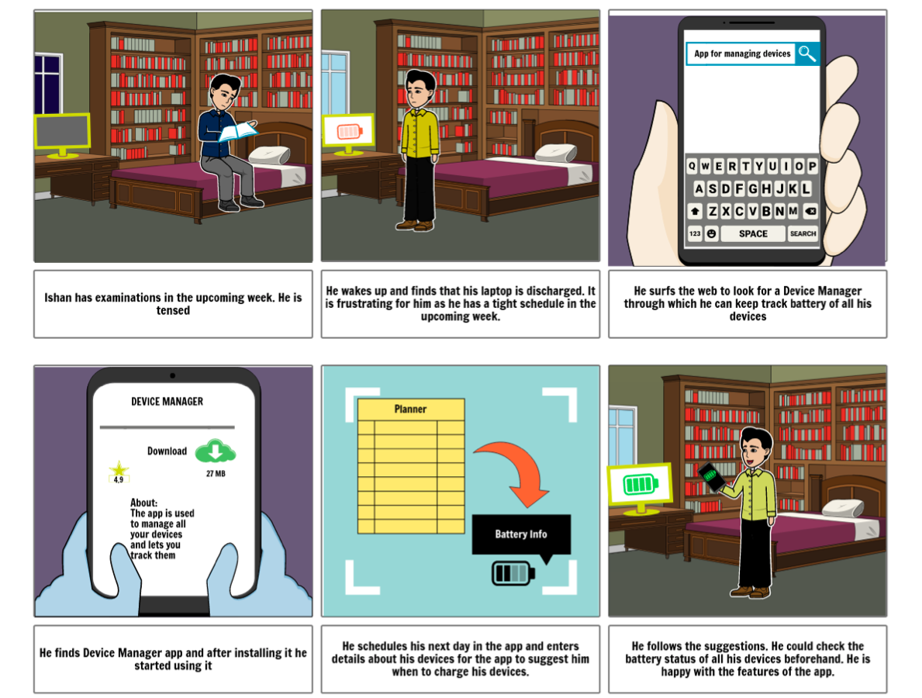

GROUP 30:

Harshal (2020062)

Rahul Jaiswal(2020109)

Mohammad Atif Quamar (2020523)

Abhishek (2020014)

Vishesh Rangwani (2020155)

**DEVICE MANAGER APP**

**STORYBOARD**

PROBLEM STATEMENT:

This app helps user to manage all their IoT devices, such as keeping remote track of battery status of the devices and letting the user track them.